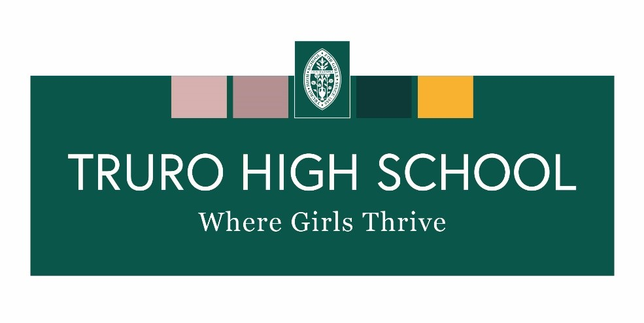
Boarding Weekend Activities
Summer Term 2024 (First half)

N.B. As much as we’re really hoping to do all of these things, they will always be subject to numbers, Cornish weather, transport and boarders’ suggestions
Please let us know if there is anything you would really like to do!

Date | Activities
19/20/21 April | Friday – Ice Cream Factory  Saturday – Horse Riding (extra cost of £30)  Sunday - Coast path walk
26/27/28 April | Friday – Games night  Saturday – Camel Trail  Sunday – Beach visit
3/4/5/6 May | Friday – Smores  Saturday – Surf Lesson (yr 7 & 8 Occasional weekend)  Sunday – St Ives visit  Bank Holiday Monday – Carboot sale
10/11/12 May | Friday – Perfume making  Saturday – SUP boarding  Sunday – Walk
17/18/19 May | Friday – Big screen movie night in Piran  Saturday – Sushi Making  Sunday – Aqua park
 | Half Term

Some of these trips may carry small additional charges that can be added to your termly bill. You will be told about this closer to the time.

